Shatford Memorial Elementary School
Family Spaghetti Dinner
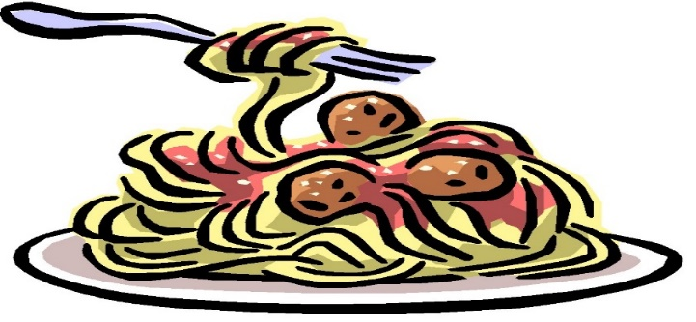

Warm up your winter blues with a delicious Spaghetti dinner!!
Shatford will be hosting a family dinner and dessert on January 31th 2020, dinner will be served between 4:30-6:30.
Tickets will be pre-sold for this event.

Tickets: - Single serving $2.00
- Family serving $8.00 (no max)
Spaghetti Options: - Meat
-Veggie
- Gluten Free noodles upon req.
Please send cash only and fill out attached form with above information. Forms due back by Monday Jan. 27th 2020 as we have to purchase food for this event.
Please note this is not a fundraiser, all proceeds for this event go towards the cost of this dinner.
We hope to see all of our wonderful Shatford families at this event!!!
Please send this form back with money for this event.
Once received in the office, tickets for this event will be sent home with your child the day before the event (Jan. 30th).
A ticket will need to be presented upon arrival at the dinner in order to receive your meal. Please note all meals come with a gingerbread dessert.
We do ask families to please bring water bottles as a drink. Coffee/Tea will be provided by the school.

Shatford Memorial Elementary School
Family Spaghetti Dinner
Family Name and first names of all attending: | Meat Spaghetti (number of plates)  _______________
Veggie Spaghetti (number of plates)  _______________ | Gluten Free Noodles (number of plates)  __________________

Total $___________________

